Cursive Writing

A1 ($40 plus tax and shipping) | 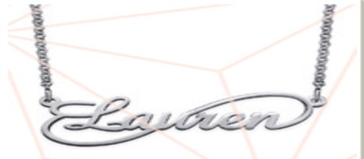
A2 ($39 plus tax and shipping) | 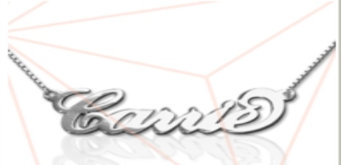
A3 ($40 plus tax and shipping) | 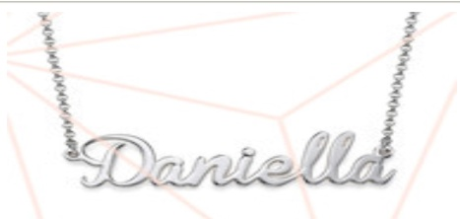
A4 ($45 plus tax and shipping) | 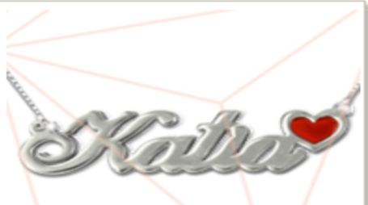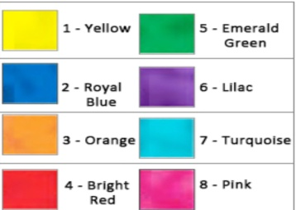
A5 ($50 plus tax and shipping) | 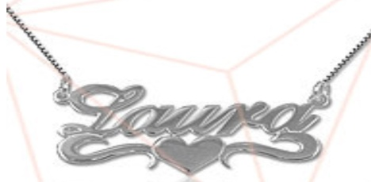
A6 ($48 plus tax and shipping) | 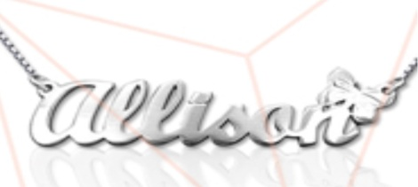
A7 ($48 plus tax and shipping) | 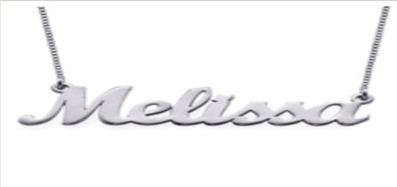

Manuscript Writing

A8 ($38 plus tax and shipping) | 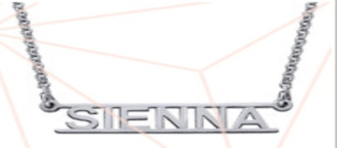
A9 ($44 plus tax and shipping) | 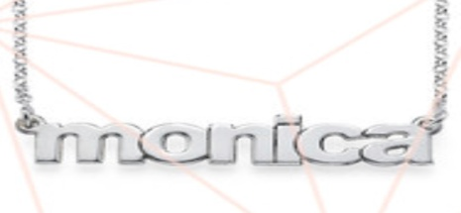
A10 ($37 plus tax and shipping) | 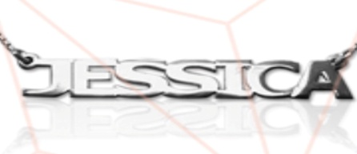
A11 ($40 plus tax and shipping) | 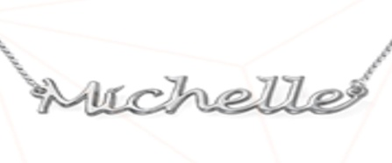
A12 ($44 plus tax and shipping) | 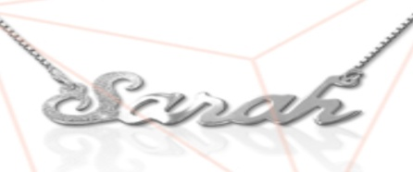
A13 ($40 plus tax and shipping) | 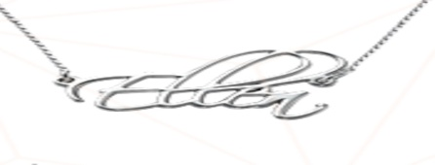

First
Complete the Order Form #1 for Personalized Name Necklace

Style Number (The highlighted letter and number):
Type the style number in the box. (If you select A4 please select your color ex. A43 the last number represents the color)

Length of chain: (14 young adult, 16, 18, 20, 22 inches) see last page for length diagram.
Type the length in the box.

Type the name as it would appear on the necklace. You cannot alter the font. Please double check the spelling. (max. 9 letters)

Order Form #2 for Personalized Name Necklace (Optional)
Style Number (The highlighted letter and number):
Type the style number in the box. (If you select A4 please select your color ex. A43 the last number represents the color)

Length of chain: (14 young adult, 16, 18, 20, 22 inches) see last page for length diagram.
Type the length in the box.

Type the name as it would appear on the necklace. You cannot alter the font. Please double check the spelling. (max. 9 letters)

Necklace Length Chart

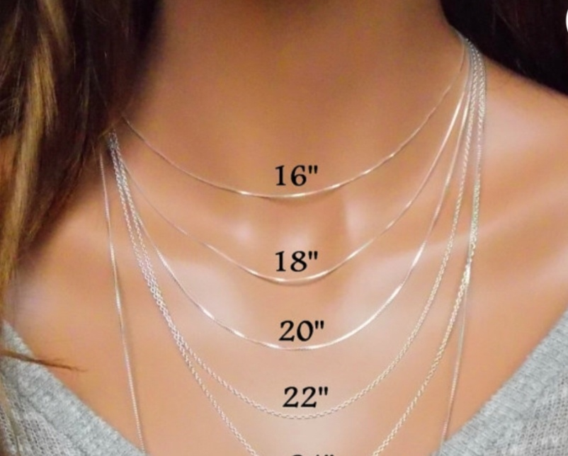
Damaged or Incorrect Product
In the unlikely event that you receive a damaged or incorrect product or if your product is damaged during normal usage, we will happily fix or exchange the item free of charge or send you a full refund upon receipt of the returned item. Please notify us immediately. All our products automatically include a 6 Months Limited Warranty.

Next
Ship to:
(Type the shipping address in the circle)

Lastly
Please send your order form to anaccessoryobsession@gmail.com and in the subject line put your name /personalized necklace. An invoice will be generated and sent via email. Once your invoice is satisfied please allow 2 days for processing and 2.5-3 weeks for delivery. ALL SALES ARE FINAL.

Accessory Obsession appreciates your business. Have a fashionable day!

